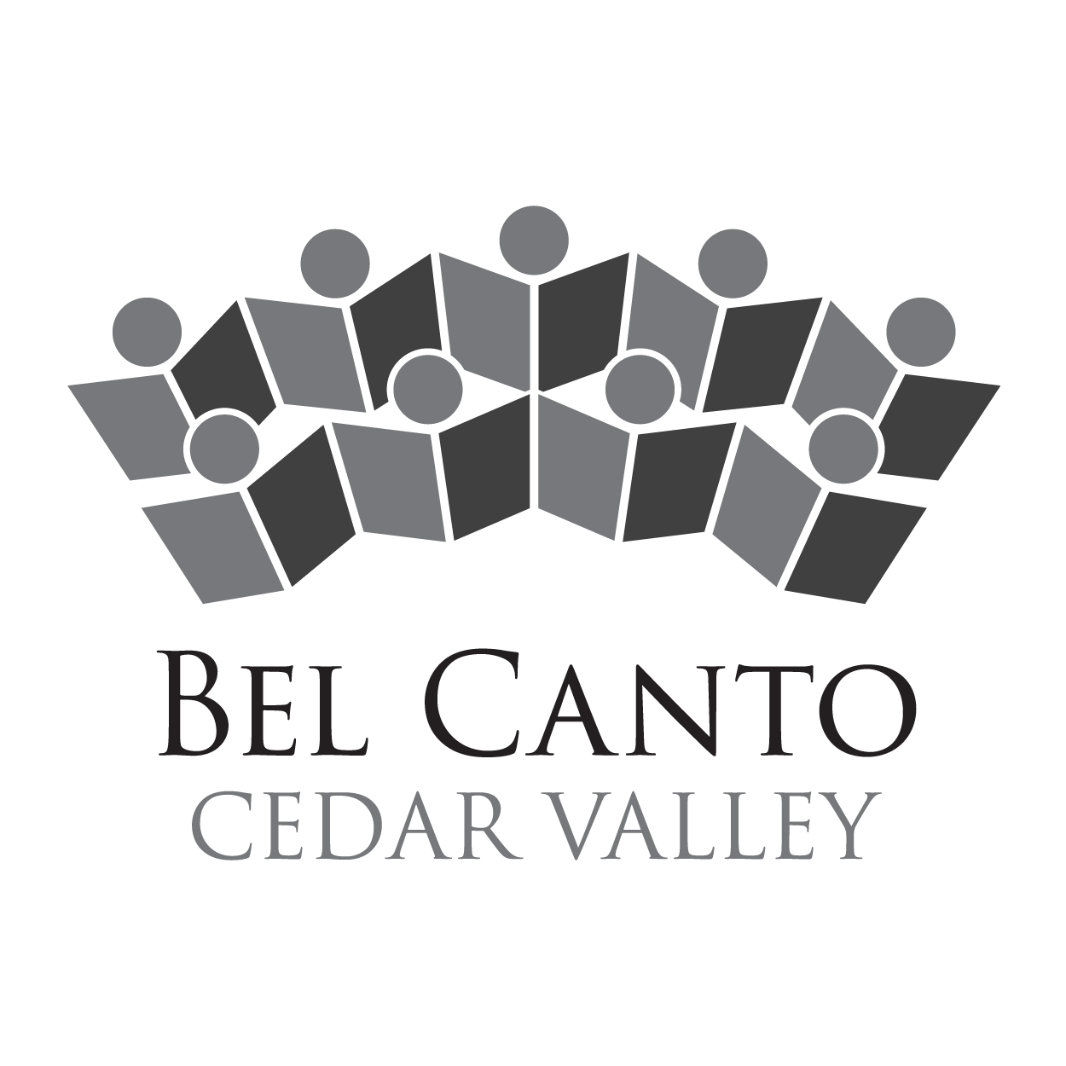

Bel Canto Cedar Valley

Contact: Stephanie Klemetson FOR IMMEDIATE RELEASE
Tel: 651-528-9673
Email: president@belcantocedarvalley.org

Bel Canto Cedar Valley to celebrate five-year anniversary in song with Dike-New Hartford choir

Bel Canto Cedar Valley will present “How Can We Keep from Singing,” at 3 p.m. Sunday, May 7 at First Congregational Church in Waterloo.

The concert will choral favorites by Mozart, Eric Whitacre, John Rutter, Rene Clausen, Moses Hogan, and many more. The choir will also perform original compositions by Devin Wipperman and Nick Klemetson, interim artistic director.

The Dike-New Hartford high school choir will perform with Bel Canto and also perform solo pieces at the event.

Admission is $10 for the hour-long concert. Tickets can be purchased ahead from chorale members, online at www.belcantocedarvalley.org, or at the door. A dessert reception will follow the concert.

Bel Canto Cedar Valley (BCCV), founded in 2012 by Alice Reid Pruisner, promotes quality choral music in Northeast Iowa, explores the breadth of choral repertoire, advances new choral music from regional composers, and encourages music as a life-long passion. BCCV members come from communities all around the Cedar Valley including Waterloo, Cedar Falls, Waverly, Hudson, Denver, New Hartford, Reinbeck, and many others. Visit www.belcantocedarvalley.org for more information.

This concert is made possible through generous support from the Community Foundation of Northeast Iowa.

###

For more information, or to schedule an interview, please contact Stephanie Klemetson at 651-528-9673 or president@belcantocedarvalley.org.

